**Setting Up The Lab**

* For any penetration testing first of all we need to set a Lab.
* The lab can be set in two modes.They are:

(a) *Live mode*

(b) *Virtualization mode*

* In the case of the live mode the testing can be done by using the OS in live.
* In the Virtualization mode we have to install Virtual Box in the host machine. The Download Link is given below.
* Download link is:

https://www.virtualbox.org/wiki/Downloads

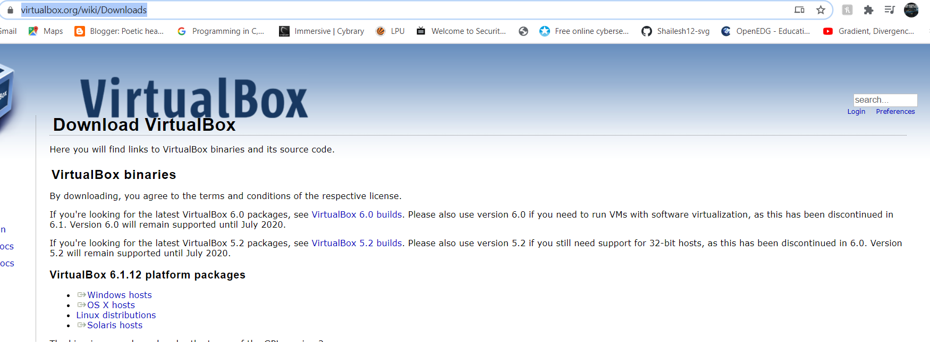

* For setting up the testing lab, first we have to open the virtual box.
* After opening the Screen looks like this.

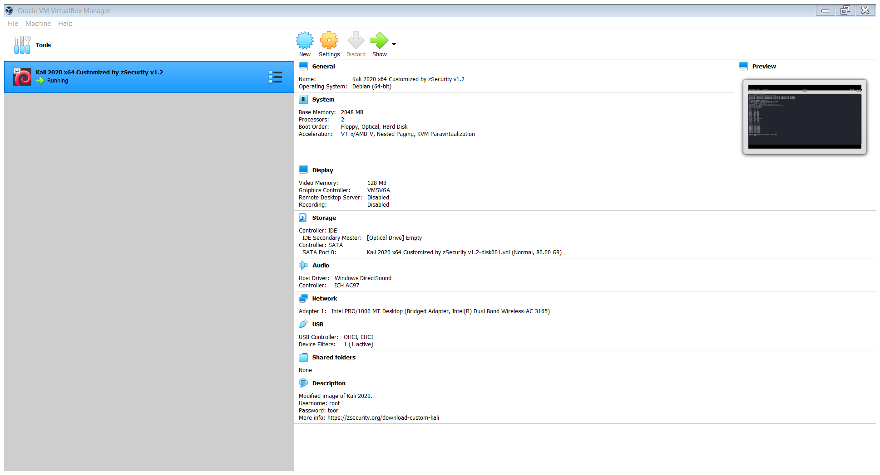

* Next we have to click on machine and the screen looks like this and Click on New.

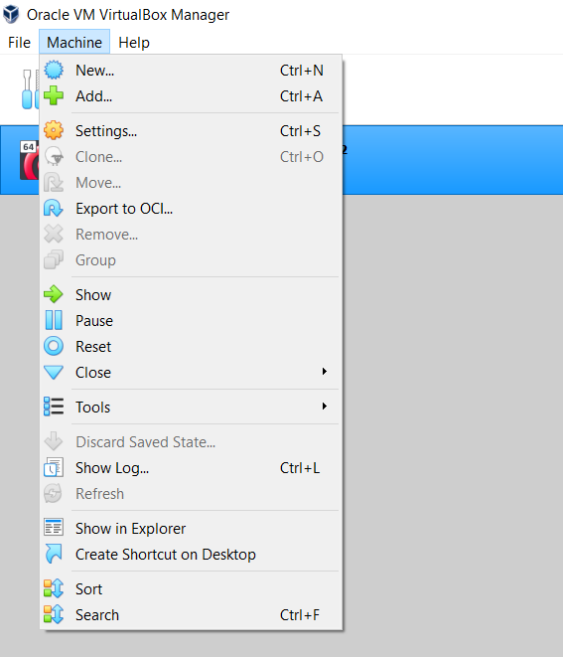

* Then the screen will look like this.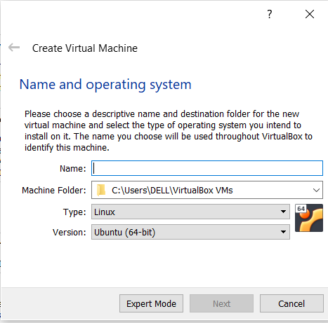
* Fill the name of lab as per your choice .Then Select Linux in type and Ubuntu(64-Bit)in version and click on next.
* Then the screen will look like this.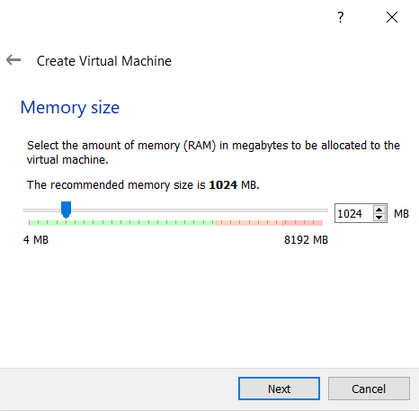
* Allocate the memory (RAM) not less than 2GB and click Next. The Screen will be like this:

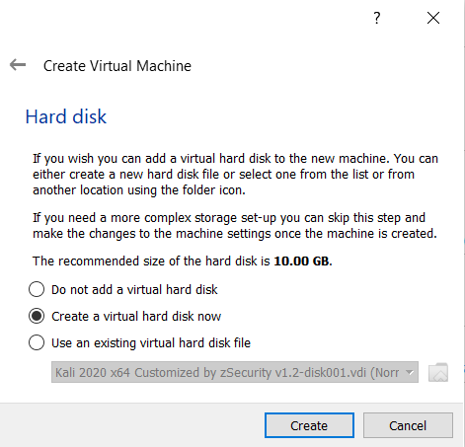

* Then Select on create a virtual hard disk now and Click on Create. The screen will look like this.

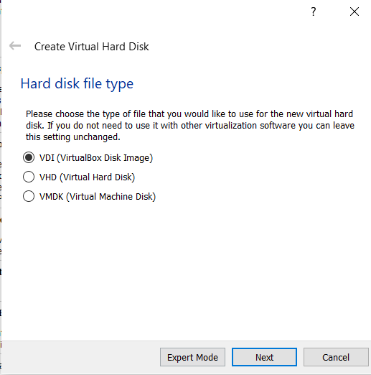

* Click on VDI (Virtual Disk Image) and click next

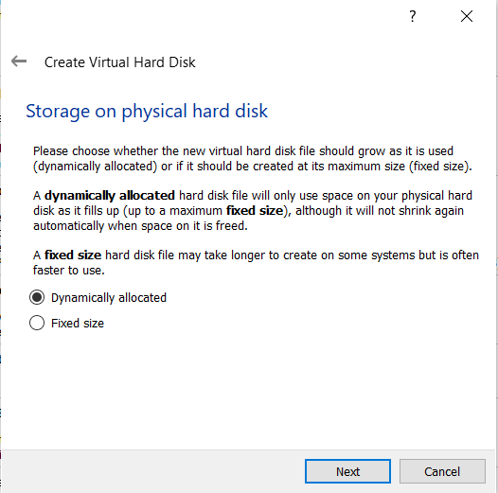

* Then allocation of Size upto 20GB and Click On create.

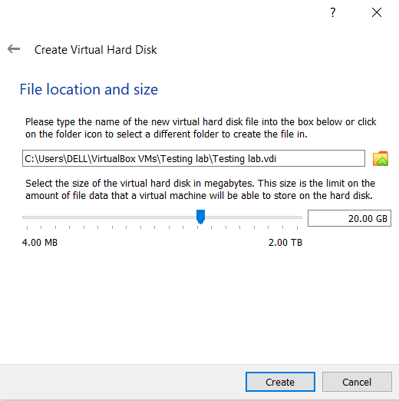

* Hence Lab is created just Add Iso file in that configure it and We are ready.